**Project on:**

**Operating System: Graphical simulator for Resource Allocation Graphs (RAG)**

**(Lovely Professional University)**



**Prepared By:**

**1. KAUSHAL KISHOR (Reg.no- 12312824)**

**2. AMAN KUMAR (Reg.no- 12318896)**

**3. ANAND KUMAR (Reg.no- 12320597)**

**Submitted To:**

**Dr. Parvinder Singh (UID: 31042)**

**ABSTRACT:**

Efficient resource allocation is a critical function of operating systems (OS), ensuring that multiple processes can share limited resources without conflicts. Poor resource management can lead to issues such as **deadlocks, starvation, and performance degradation**, making it essential to understand resource allocation mechanisms. To aid in this understanding, this project presents a **Graphical Simulator for Resource Allocation Graphs (RAGs)**, designed to visually represent and analyse resource allocation in an OS environment.

The simulator provides an interactive platform where users can create and manipulate process-resource relationships, observe resource allocation dynamics, and detect potential deadlocks. It implements fundamental deadlock detection and prevention algorithms, such as Banker’s Algorithm, Wait-for Graph analysis, and Deadlock Avoidance strategies, allowing users to experiment with different allocation scenarios. Through visual representation, the simulator highlights dependencies, unsafe states, and system behaviour, making abstract concepts more tangible.

Key findings from the development and testing of the simulator show that graphical visualization significantly enhances comprehension of OS resource management. The ability to interact with resource allocation graphs in real time provides users with deeper insights into safe sequences, deadlock conditions, and optimization techniques. The simulator serves as an educational tool for students learning OS concepts and as a testing framework for developers analysing resource allocation policies.

**Table of Contents:**

1. **Introduction**

1.1 Introduction to Operating Systems

* 1. Introduction to Resource Allocation Graphs (RAGs):

**2. Objective of the Graphical Simulator**

2.1. To Provide a Dynamic Visualization of Resource Allocation Graphs for Better Understanding

2.2. To Allow Users to Create, Modify, and Analyze Resource Allocation Scenarios Interactively

2.3. To Simulate Deadlock Detection and Prevention Techniques

2.4. To Bridge the Gap Between Theoretical Learning and Practical Application

**3.MODULE WISE BREAKDOWN**

3.1 Module 1: GUI & User Interaction

3.1.1. PURPOSE

3.1.2. Role

3.2 Module 2: Graph Data Handling & Deadlock Detection

3.2.1. PURPOSE

3.2.2. Role

3.3. Module3: Data Visualization & Simulation

3.3.1. PURPOSE

3.3.2. Role

**4.Functionalities:**

4.1 Key Features- Module 1: GUI & User Interaction

4.1.1 Example Use Case- Module 1: GUI & User Interaction

4.2 Key Features- Module 2: Graph Data Handling & Deadlock Detection

4.2.1 Example Use Case- Module 2: Graph Data Handling & Deadlock Detection

* 1. Key Features-Module 3: Data Visualization & Simulation

4.3.1. Example Use Case- Module 3: Data Visualization & Simulation

**5.Technology Used:**

5.1 Programming Languages

5.1.1. Ease of Use

5.1.2 Simplicity in GUI Development

**6.Libraries and Tools:**

6.1. Strong Library Support: Python Offers “network” and “matplotlib”

6.2. NetworkX for Graph Management and Deadlock Detection

6.3. Features Used in the Project:

6.3.1. Graph Creation (nx.DiGraph())

6.3.2. Adding Nodes Dynamically

6.3.3. Deadlock Detection (nx.simple_cycles())

6.3.4. Matplotlib for Graph Visualization

**7. Flow Diagram**

**8. Revision Tracking on GitHub**

**9. Conclusion:**

**10.Future Scope:**

10.1. Enhancing User Interface and Experience

10.2. Advanced Deadlock Detection and Recovery Mechanisms

10.3. Multi-Threading and Real-Time Simulation

10.4. Integration with Real-World Systems

10.5. AI and Machine Learning for Resource Optimization

10.6. Collaborative and Multi-User Functionality

10.7. Extended Support for Additional Algorithms and Policies

**11.FINAL CODE**

**12.SOLUTION OF CODE**

**1. INTRODUCTION:**

**1.1** **Introduction to Operating Systems:**

An **Operating System (OS)** is a fundamental software that manages computer hardware and software resources, providing a user-friendly interface for interaction. It acts as a bridge between **users, applications, and hardware**, ensuring efficient execution of programs and optimal resource utilization. Modern operating systems are responsible for process management, memory management, file handling, device management, and security. One of the most critical aspects of an OS is resource allocation, which involves distributing system resources like CPU time, memory, I/O devices, and storage among multiple processes.

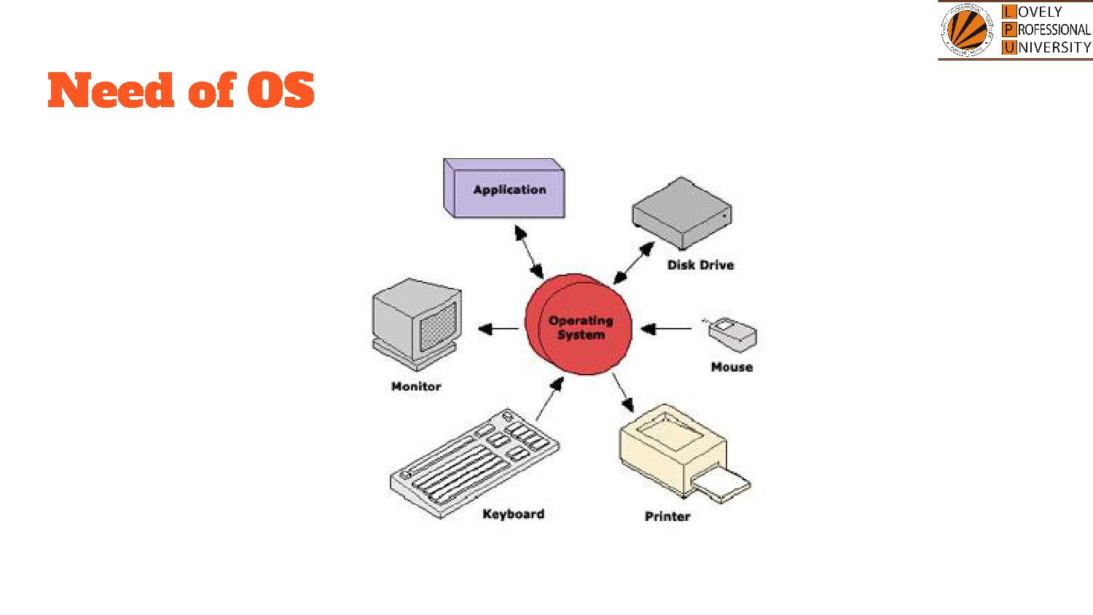

1). An **application** is a software program that runs on top of the operating system. The OS provides the necessary resources, such as memory, processing power, and access to hardware, to ensure smooth execution and functionality of applications.

2.) The **disk drive** is responsible for storing data and programs permanently. The OS manages file systems, read/write operations, and data retrieval, allowing users to save, access, and modify files efficiently.

3.) The **mouse** is an input device used for navigation and selection. The OS interprets mouse movements and clicks, enabling users to interact with graphical user interfaces, select files, and operate applications smoothly.

4.) The **printer** is an output device used for printing documents and images. The OS manages print queues, drivers, and communication with the printer, ensuring efficient printing operations and handling multiple print requests.

5.) The **keyboard** is the primary input device for typing commands and text. The OS processes keystrokes, maps them to corresponding characters or actions, and facilitates user interaction with applications and system functions.

6.) The **monitor** is a visual output device that displays the user interface, graphics, and system information. The OS controls screen resolution, rendering, and display settings to provide a clear and interactive user experience.

By managing these components, the OS ensures seamless communication between hardware and software, enabling efficient operation and user interaction with the computer system.

In **multi-user and multi-tasking environments**, efficient resource allocation is essential to **maximize system performance and prevent conflicts**. However, improper allocation may lead to critical problems like **deadlocks, starvation, and resource contention**, affecting system reliability. To understand and manage these issues, **Resource Allocation Graphs (RAGs)** are widely used in OS theory. These graphs visually represent the relationships between **processes and resources**, helping in the analysis of **safe and unsafe states**, as well as in detecting and preventing deadlocks.

**Importance of Resource Allocation in Operating Systems**

Resource allocation is crucial for ensuring that all processes receive the necessary resources without conflicts. Some key challenges include:

* **Deadlocks** – A state where processes wait indefinitely for resources held by other processes.
* **Starvation** – Some processes may never get resources due to priority-based allocation.
* **Resource Contention** – Multiple processes compete for limited system resources, reducing efficiency.

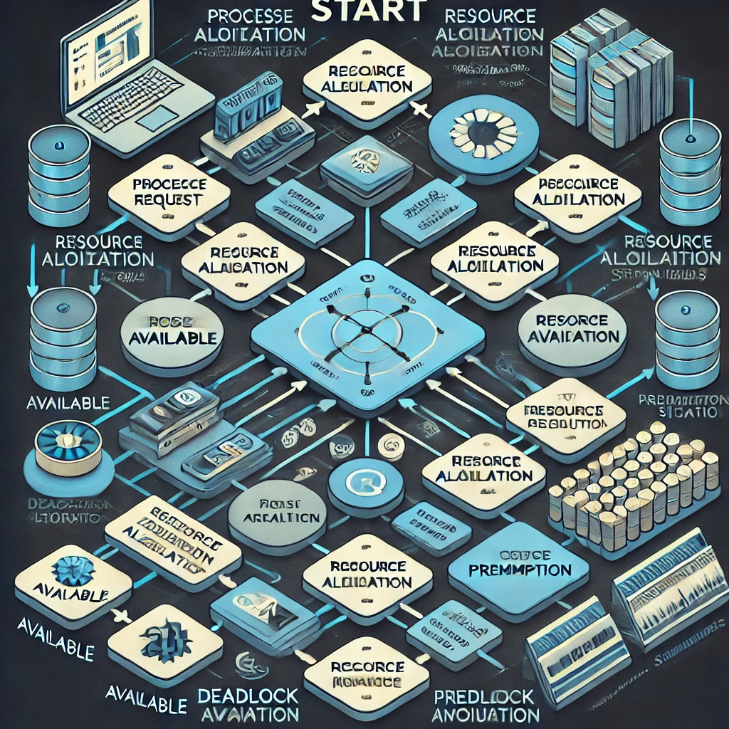

Operating systems use various techniques like **Banker’s Algorithm, Deadlock Prevention, and Avoidance Strategies** to manage resource allocation effectively. However, understanding these theoretical concepts can be challenging for students and researchers without a **visual representation**.

**1.2 Introduction to Resource Allocation Graphs (RAGs):**

A **Resource Allocation Graph (RAG)** is a **directed graph** used in operating systems to model the allocation of resources to processes. It helps in visualizing resource management, tracking dependencies, and detecting potential deadlocks. In a RAG, processes and resources are represented as nodes, while edges denote resource requests and allocations. A directed edge from a **process to a resource (P → R)** indicates that the process is requesting the resource, while an edge from a **resource to a process (R → P)** signifies that the resource has been allocated. By analysing the structure of the graph, the system can identify cycles, which may indicate deadlock conditions, and take necessary actions to prevent or resolve them.

The components of a RAG include:

* **Processes (P1, P2, ... Pn)** – Represented as circles/nodes, they request and hold resources.
* **Resources (R1, R2, ... Rm)** – Represented as squares, allocated to processes based on availability.
* **Edges** – Two types of edges exist in a RAG:
  + **Request Edge (P → R)**: A process requests a resource.
  + **Assignment Edge (R → P)**: A resource is allocated to a process.

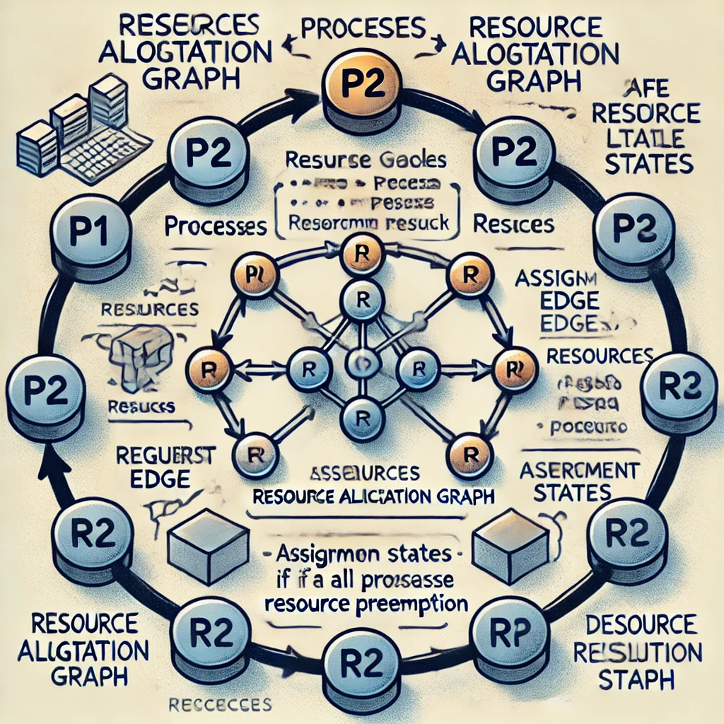

**Resource allocation graph:**

* As its name suggests, the resource allocation graph is the complete information about all the processes which are holding some resources or waiting for some resources.
* It also contains the information about all the instances of all the resources whether they are available or being used by the processes.
* In Resource allocation graph, the process is represented by a Circle while the Resource is represented by a rectangle.
* Vertices are mainly of two types, Resource and process. Each of them will be represented by a different shape. Circle represents process while rectangle represents resource.
* A resource can have more than one instance. Each instance will be represented by a dot inside the rectangle.

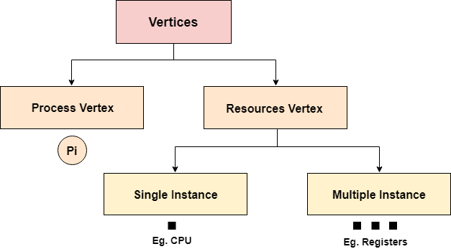

* Edges in RAG are also of two types; one represents assignment and the other represents the wait of a process for a resource.

**Assignment Edge:** An assignment edge in a Resource Allocation Graph is a directed edge from a resource to a process. This edge indicates that a process has been allocated or is currently holding a specific resource.

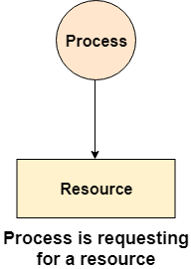

**Request Edge:** A request edge is a directed edge from a process to a resource. It indicates that a process is requesting a resource but has not yet been granted access to it.

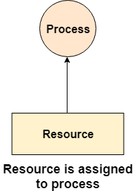

* If a cycle is detected in a **Resource Allocation Graph**, it indicates the possibility of a **deadlock**. Various algorithms help in detecting, preventing, and recovering from deadlocks using RAGs.

**Type of Resources:**

**1). Single Instances:** Single-instance resources refer to resources in a system or application that are intended to have only one active or running instance at any given time. These resources are typically unique, and their design ensures that only one copy or instance is in use, which can be useful for efficiency, control, and preventing conflicts. They can be part of various systems, such as databases, servers, applications, or services.

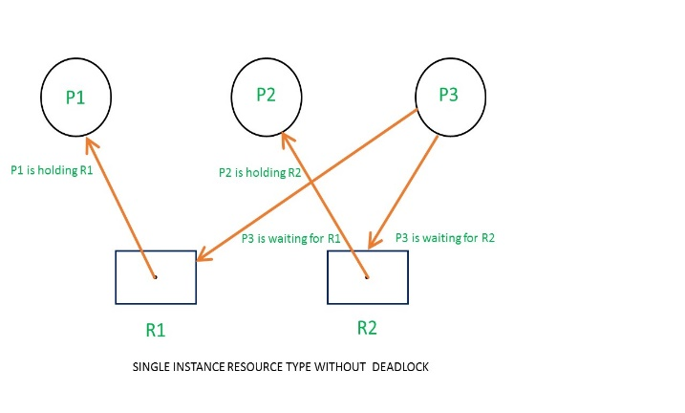

1. **Multi-Instances:** Multi-instance resources refer to situations where multiple independent instances of a resource or service can be created and used concurrently in a system. Unlike single-instance resources, which allow only one active instance at a time, multi-instance resources enable multiple copies or processes to exist and operate simultaneously. This is essential for ensuring scalability, high availability, and fault tolerance in many modern systems.

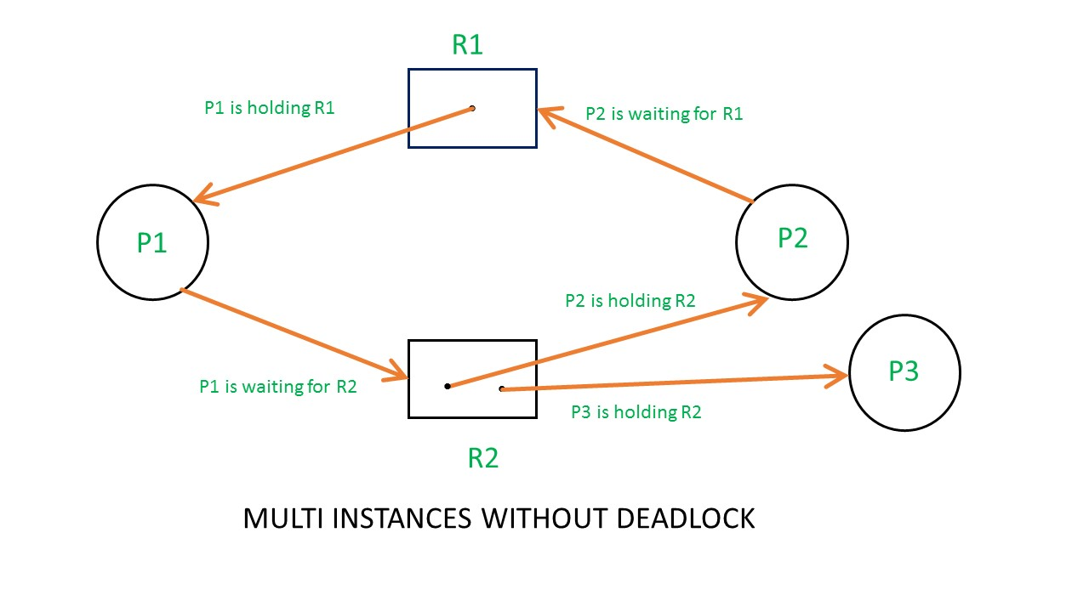

**Necessary Condition for Deadlock:**

A deadlock occurs in a system when a set of processes are permanently blocked, each waiting for a resource held by another process. For a deadlock to happen, four necessary conditions must be met simultaneously:

**1). Mutual Exclusion:** Mutual exclusion means that at least one resource cannot be shared and is available to only one process at a time. If another process requests the same resource, it must wait until the resource is released. For example, a printer being used by one process cannot be accessed by another process until it is freed.

**2.) Hold & Wait:** Processes that **already hold** some resources can **request additional resources** without releasing the ones they currently have. This can lead to a situation where multiple processes are holding some resources while waiting for others, preventing progress.

**3.) No Pre-emption:** A resource cannot be forcibly taken from a process. It must be released voluntarily by the process holding it once its execution is complete. If a process holding a resource is waiting for another resource, the system cannot take away the currently held resource to resolve deadlock.

**4.) Circular Wait:** There exists a circular chain of processes, where each process is waiting for a resource held by the next process in the chain. For example, P1 → P2 → P3 → P1, where P1 is waiting for a resource held by P2, P2 is waiting for P3, and P3 is waiting for P1. This cycle prevents any process from proceeding, causing deadlock.

**Relationship between cycles to deadlocks:**

a.) If a resource allocation graph contains no cycles, there is no deadlock.

b.) If a resource allocation graph contains a cycle and if only one instance exists per resource type, then there is deadlock

c.) If a resource allocation graph contains a cycle and if several instances exist per resource type, then possibility of deadlock.

**2.Objective of the Graphical Simulator**

Operating system concepts such as resource allocation, deadlocks, and process management are fundamental in computing, yet they are often difficult to grasp through theoretical study alone. The complexity of understanding how processes request, hold, and release resources, as well as how deadlocks occur, makes it necessary to adopt a more interactive and visual approach. A Graphical Simulator for Resource Allocation Graphs (RAGs) serves as an essential tool to enhance learning and research by visually representing process-resource interactions and allowing users to experiment with different scenarios dynamically.

**The primary objectives of this simulator are outlined below:**

**2.1.** **To Provide a Dynamic Visualization of Resource Allocation Graphs for Better Understanding**

A Resource Allocation Graph (RAG) is a directed graph that represents the allocation of resources to processes. The simulator transforms static theoretical concepts into interactive graphical representations, making it easier for students to visualize dependencies and conflicts between processes and resources.

Through dynamic updates, users can observe how new processes are introduced, resources are requested, granted, or released, and how the system state changes over time. This real-time visualization enhances comprehension by allowing users to directly see how different resource allocation policies affect system stability and efficiency.

**2.2.** **To Allow Users to Create, Modify, and Analyse Resource Allocation Scenarios Interactively**

One major limitation of traditional learning methods is the inability to modify and test real-world scenarios dynamically. The graphical simulator overcomes this by enabling users to create custom process-resource models, modify existing graphs, and analyse the effects of different resource allocation strategies.

**Users can:**

* Add or remove processes and resources.
* Define resource requests and allocations.
* Observe safe and unsafe states.
* Modify allocation rules and instantly see how changes impact the system.

This interactive feature helps learner’s experiment with different conditions, reinforcing their understanding through hands-on experience.

**2.3. To Simulate Deadlock Detection and Prevention Techniques**

Deadlocks are among the most critical challenges in resource management. A deadlock occurs when a set of processes get stuck waiting for resources held by each other, forming a circular wait. Understanding how to detect and prevent deadlocks is crucial in operating system design.

The graphical simulator incorporates algorithms like the Wait-for Graph and Banker’s Algorithm, which are essential for deadlock detection and avoidance. The simulator helps users:

* Identify deadlock-prone scenarios through cycle detection in the RAG.
* Apply Banker’s Algorithm to evaluate safe and unsafe states dynamically.
* Experiment with different allocation strategies to prevent deadlocks.

By visually highlighting deadlocked processes and showing step-by-step how the system responds, the simulator makes it easier to grasp these critical OS concepts.

**2.4. To Bridge the Gap Between Theoretical Learning and Practical Application**

Many students and researchers struggle to connect OS theory with practical implementation. The simulator serves as a bridge by bringing theoretical concepts to life through interactive learning. It allows users to simulate real-world scenarios where processes compete for limited resources, test different deadlock handling mechanisms, and explore advanced allocation strategies used in modern computing environments like multi-threading, cloud computing, and distributed systems.

By using this graphical simulator, students, educators, and researchers can:

* Explore real-world resource management challenges in an interactive environment.
* Experiment with various allocation strategies to see their effects in real-time.
* Improve their problem-solving skills by identifying and resolving deadlock conditions dynamically.



**3.MODULE WISE BREAKDOWN**

**3.1 Module 1: GUI & User Interaction**

**3.1.1 PURPOSE:**

The **Graphical User Interface (GUI)** serves as the **primary interaction layer** between the user and the **Graphical Simulator for Resource Allocation Graphs**. Its primary objective is to provide a **user-friendly and interactive environment** where users can create and manage **processes, resources, and their allocations** within the operating system's resource allocation graph.

A command-line interface (CLI) or theoretical approach can be difficult to comprehend, especially for beginners. Therefore, a well-designed GUI simplifies resource allocation concepts by allowing users to interact through buttons and input dialogs instead of writing manual commands. The GUI enables the user to:

* **Add processes and resources dynamically.**
* **Create request and allocation edges** between processes and resources.
* **Detect deadlocks** using a built-in algorithm.
* **Visualize the graph dynamically**, making it easier to interpret results.

Another essential purpose of the GUI is to make learning resource allocation and deadlock detection interactive and engaging. It bridges the gap between theory and practice by allowing users to modify the system’s state in real time and immediately see how those changes affect the system.

**3.1.2 Role:**

The GUI acts as a command center for the simulator, facilitating seamless interaction with the underlying logic of the program. It plays a crucial role in:

1. **User Input Handling:** The GUI provides input fields where users can enter the names of processes and resources. It ensures only valid inputs are accepted and prevents duplicate entries.
2. **Graph Control:** The GUI allows users to modify the resource allocation graph using simple button clicks rather than complex coding or manual graph creation. Users can add nodes (processes/resources) and edges (allocations/requests) dynamically.
3. **Deadlock Detection Execution:** The GUI enables users to trigger deadlock detection with a single click, providing immediate feedback on whether a deadlock is present. If a cycle is detected in the graph, the system warns the user.
4. **Graph Display & Visualization:** The GUI integrates with the visualization module to show the current state of the resource allocation graph. It updates automatically when changes occur, providing a real-time graphical representation.
5. **Error Handling & Notifications:** The GUI validates inputs and provides user-friendly messages in case of incorrect operations (e.g., trying to add a duplicate process or requesting an invalid resource).

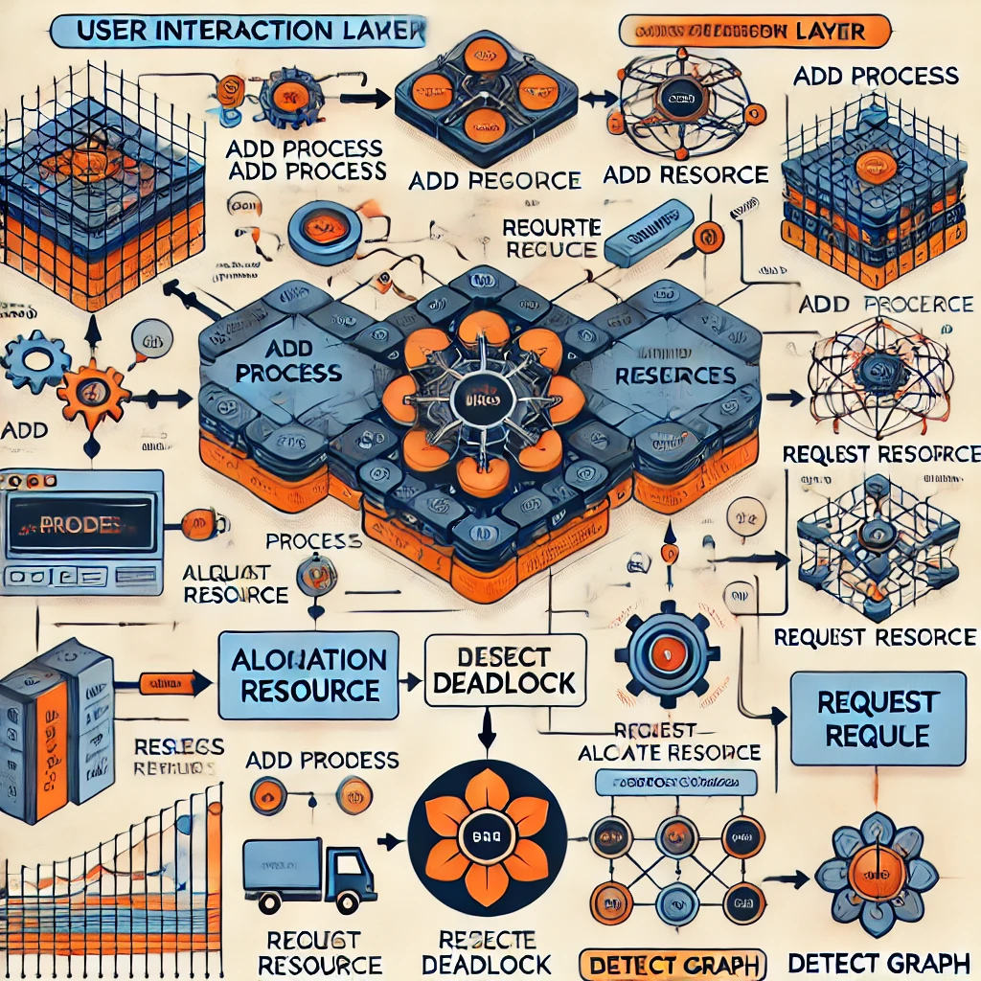

Overall, the GUI simplifies the complex interactions required to build, analyse, and understand resource allocation in an operating system. It ensures a smooth user experience while allowing users to experiment with different allocation scenarios, deadlock conditions, and recovery strategies in an intuitive manner.

**3.2 Module 2: Graph Data Handling & Deadlock Detection**

**3.2.1 PURPOSE:**

This module is responsible for managing the **data structure** behind the resource allocation graph. It ensures that all **processes, resources, and their relationships** are properly represented in a directed graph structure.

A **Resource Allocation Graph (RAG)** is used to model the allocation of resources to processes. The **purpose of this module** is to:

1. **Maintain a structured representation** of the RAG using NetworkX (a Python graph library).
2. **Ensure correct addition and removal of processes/resources** while maintaining graph consistency.
3. **Establish request and allocation relationships** by adding edges to the graph dynamically.
4. **Detect deadlocks** by identifying cycles in the directed graph structure.

This module is crucial because incorrect resource management can lead to inconsistencies, which may result in improper deadlock detection. It ensures that alloperations conform to operating system principles while accurately modelling real-world resource allocation behaviour.

**3.2.2 ROLE:**

The **Graph Data Handling & Deadlock Detection module** acts as the **logical engine** of the simulator. It interacts with the GUI by executing commands related to **process and resource management**, ensuring data integrity and handling the **detection of deadlocks**. Its responsibilities include:

1. **Graph Management:** The module is responsible for creating and maintaining a directed graph that represents the relationship between processes and resources in a system. This graph helps in visualizing and managing resource allocation, ensuring that all interactions between processes and resources are structured and traceable. It plays a crucial role in monitoring dependencies, detecting deadlocks, and ensuring smooth process execution. Where:

**Processes as Nodes**: In this directed graph, processes are represented as nodes to signify active tasks that require resources for execution. Each process node interacts with resource nodes by requesting or holding resources. This representation helps in tracking which processes are waiting for resources, and which are actively utilizing them, making it easier to analyse system behaviour.

**Resources as Nodes:** Similar to a process, resources are also represented as nodes in the graph. These nodes indicate system resources such as CPU time, memory, or I/O devices that are allocated to processes. Representing resources as distinct nodes allows the system to efficiently manage their availability and track which processes are utilizing or requesting them**.**

**Edges Representing Requests and Allocations:** The relationships between process and resource nodes are depicted through edges in the directed graph. An edge from a process to a resource represents a request, meaning the process is waiting for the resource to become available. Conversely, an edge from a resource to a process represents an allocation, indicating that the resource has been assigned to the process. This structure helps in analysing dependencies and detecting cycles, which are critical for deadlock detection and resource management.

1. **Resource Allocation & Requests:** The module is responsible for managing user actions related to process-resource interactions through the GUI. It ensures that all resource requests and allocations are handled correctly, maintaining system stability and preventing conflicts.
   * **Request edges** (P → R): When a process requests a resource.
   * **Allocation edges** (R → P): When a resource is allocated to a process.
2. **Deadlock Detection:** It runs **cycle detection algorithms** to check for circular wait conditions, which indicate a deadlock. If a cycle is found, the system alerts the user.
3. **Error Prevention & Handling:** This module prevents incorrect operations such as:
   * Adding duplicate processes/resources.
   * Creating invalid request or allocation edges.
   * Performing deadlock detection on an empty or invalid graph.

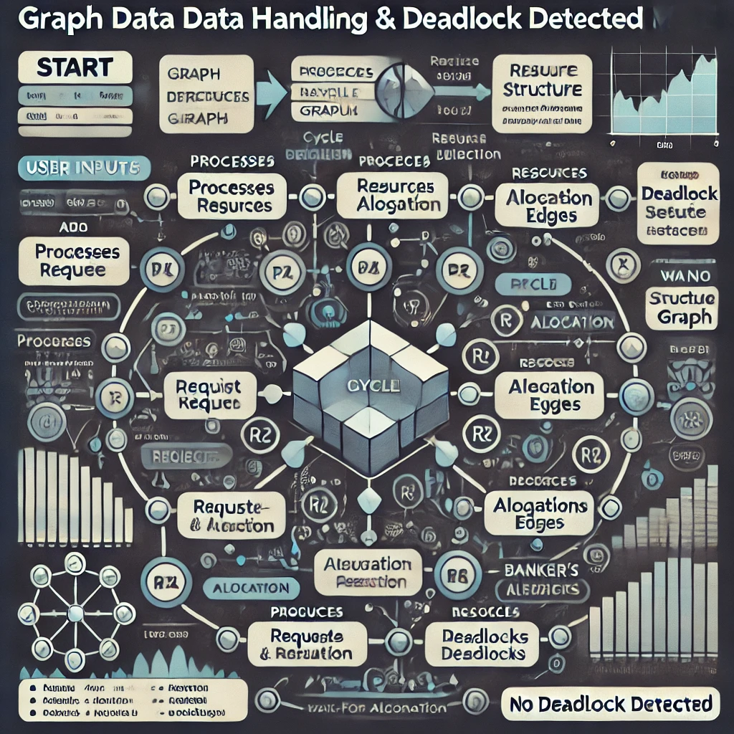

By ensuring proper graph structure and real-time deadlock detection, this module enhances the accuracy and reliability of the resource allocation simulation.

**3.3. Module3: Data Visualization & Simulation**

**3.3.1 PURPOSE:**

The main objective of this module is to visually represent the resource allocation graph in a way that is easily understandable for users. A textual or tabular representation of process-resource interactions can be difficult to interpret, especially when dealing with multiple processes and resource requests.

By incorporating graphical visualization, this module helps users see the current state of resource allocation and understand how changes in allocation affect the system. The visualization dynamically updates whenever a user:

* Adds a **new process or resource**.
* Creates a **request or allocation edge**.
* Triggers **deadlock detection**.

The purpose of visualization is to make theoretical concepts intuitive and interactive, allowing students, educators, and researchers to analyse resource allocation scenarios in a real-world, graphical format.

**3.3.2 ROLE:**

This module plays a crucial role in simulating and displaying the resource allocation graph, making it easier for users to observe how processes and resources interact.

1. **Graph Construction:**
   * Uses **NetworkX and Matplotlib** to draw and position the graph dynamically.
   * Displays **nodes as processes (circles) and resources (squares)** with different colors for better distinction.
   * Uses **edge colors** to indicate relationships:
     + **Orange for requests (P → R).**
     + **Green for allocations (R → P).**
2. **Graph Updates:**
   * Whenever a user **adds, removes, or modifies** a process/resource, the visualization **automatically updates**.
   * Helps users track the **system state in real-time**.
3. **Deadlock Representation:**
   * If a deadlock is detected, the affected **processes and resources** are highlighted.
   * This helps users **understand how deadlocks form** and experiment with ways to **prevent them**.
4. **Simulation of Different Scenarios:**
   * Users can modify allocation strategies and analyse their impact on system stability.
   * Encourages hands-on learning by allowing **real-time experimentation** with different configurations.

This module transforms a complex theoretical topic into an intuitive and interactive experience, making it easier to grasp resource allocation, process synchronization, and deadlock handling in operating systems.

**4.Functionalities:**

**4.1 Key Features- Module 1: GUI & User Interaction**

1) **Graphical User Interface (GUI)** – Provides a user-friendly environment for interacting with resource allocation graphs.  
2) **Button Controls for Operations** – Users can add, remove, and allocate processes and resources using button-based controls.  
3) **Dialog-Based Input System** – Accepts user input for process and resource names dynamically.  
4) **Error Handling & Notifications** – Alerts users for invalid operations (e.g., duplicate processes).  
5) **Deadlock Detection & Visualization** – Users can detect and highlight deadlocked processes.

**4.1.1 Example Use Case- Module 1: GUI & User Interaction**

1. A user clicks "Add Process" → Enters "P1" → A new process P1 appears in the RAG.
2. Then, they click "Request Resource" → Enter "P1" and "R1" → A request edge is created.

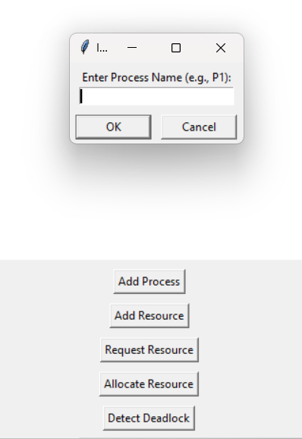

**STEP-1** user clicks "Add Process"

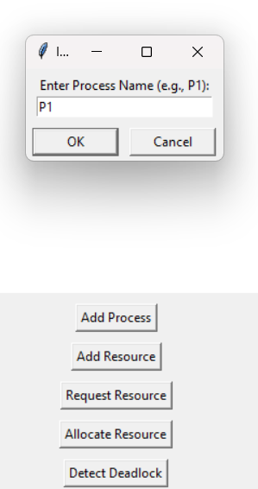



**STEP-2** A new process P1 appears in the RAG

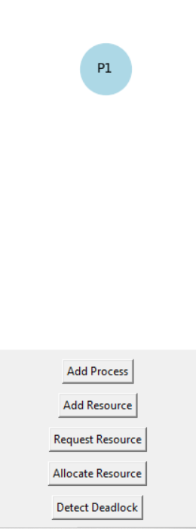

**STEP-3** AddResource

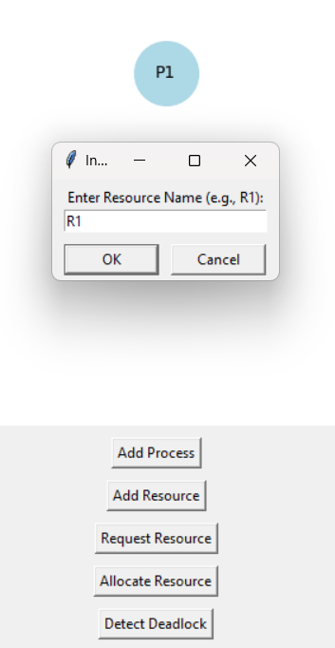



**STEP-4** Both P1 and R1 are alloacted

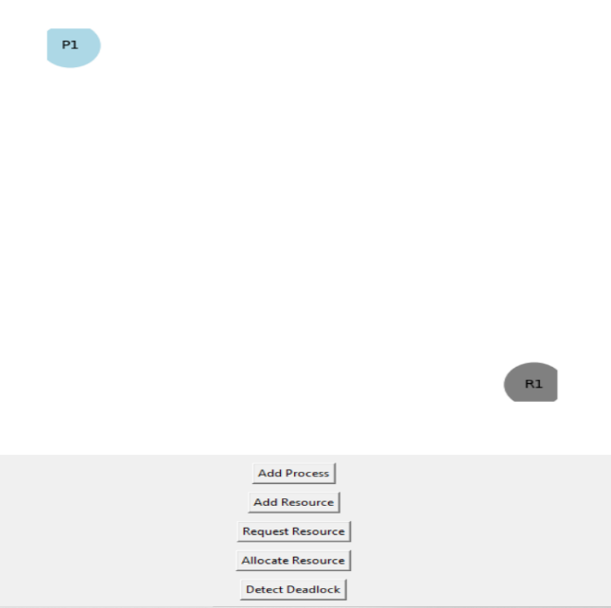

**STEP-5** Click on Request Resource ->

A **request edge** is created

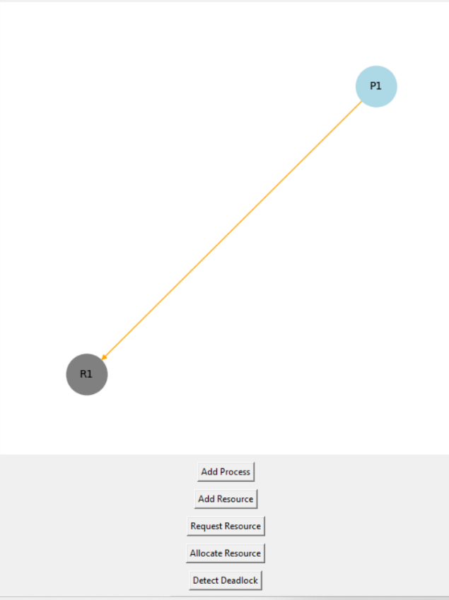



**4.2 Key Features- Module 2: Graph Data Handling & Deadlock Detection**

1) **Dynamic Graph Management** – Maintains a directed graph (DiGraph) representing resource allocation.  
2) **Process and Resource Nodes** – Processes (Blue) and Resources (Gray) are nodes in the graph.  
3) **Request and Allocation Edges** –

* Orange Edge (P → R): Process requesting a resource.
* Green Edge (R → P): Resource allocated to a process.  
  **a)** **Deadlock Detection Algorithm** – Identifies cycles in the graph using cycle detection.  
  **b)** **Wait-for Graph (WFG) Conversion** – Converts RAG into WFG for analyzing process dependencies.

**4.2.1 Example Use Case- Module 2: Graph Data Handling & Deadlock Detection**

1. A user requests a resource (P1 → R1).
2. Another process (P2) requests R1 while holding another resource.
3. A cycle forms, causing a deadlock.
4. The simulator detects and highlights P1 and P2 in a warning message.

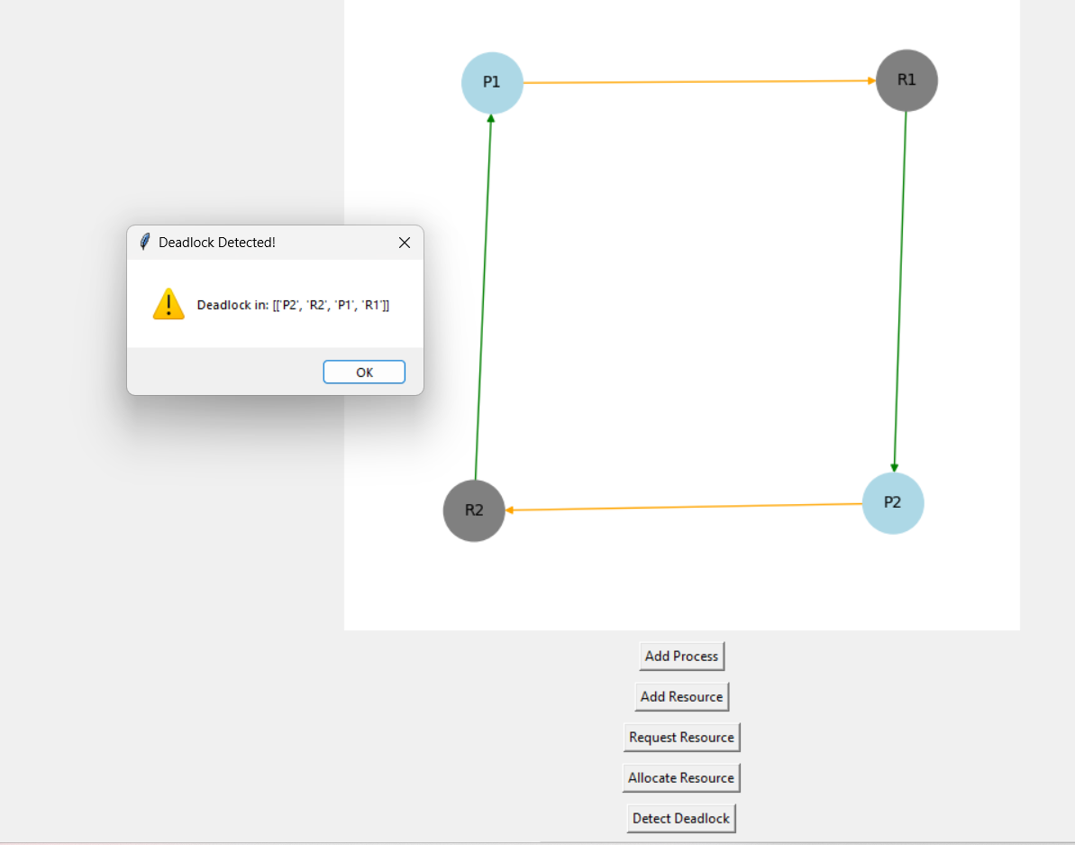

**4.3 Key Features-Module 3: Data Visualization & Simulation**

1) Real-Time Graph Updates – Visualizes RAG instantly when changes occur.  
2) Node & Edge Colouring:

* **Processes (Blue), Resources (Gray**).
* **Request Edges (Orange), Allocation Edges (Green).**
* **Deadlocked Nodes** (Red) for easy identification.  
  a**) Graph Layout Adjustments** – Uses networkx and matplotlib to create spring-based layout.  
  b**) Banker’s Algorithm Integration** – Ensures resources are allocated only if they keep the system in a safe state.  
  c) **Interactive Deadlock Resolution** – Users can remove edges/processes to resolve deadlocks.

**4.3.1 Example Use Case- Module 3: Data Visualization & Simulation**

1. The user adds multiple processes and resources.
2. They create request & allocation edges → The graph visually updates.
3. A deadlock is detected → Red highlights on deadlocked processes.
4. The user removes a process → Deadlock disappears → Graph updates dynamically.

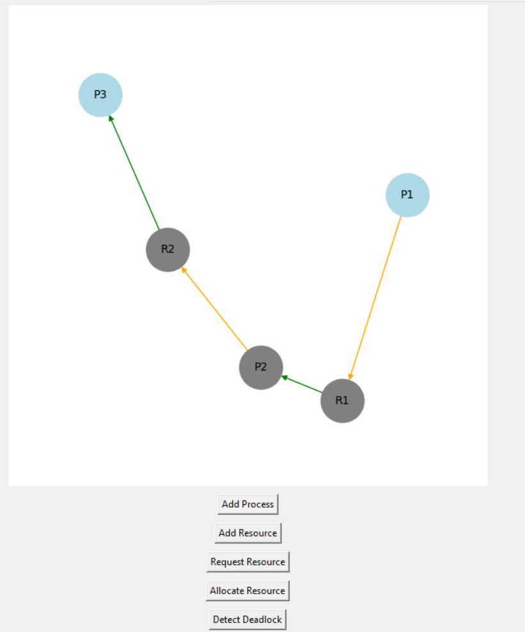

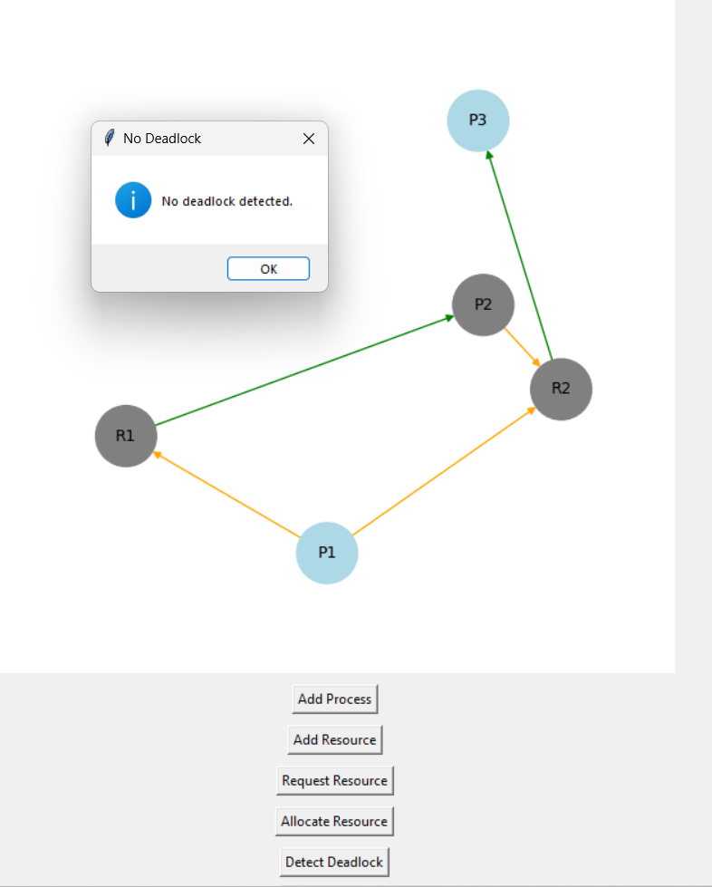

1. **Technology Used:**

**5.1 Programming Languages:** “**Python”** was chosen as the primary programming language for the Graphical Simulator for Resource Allocation Graphs because of its ease of use, strong library support, and cross-platform compatibility. Below is a detailed analysis of why Python is the best fit for this project.

**5.1.1. Ease of Use:** Python Simplifies GUI and Graph Handling

Python is known for its simple syntax and readability, making it easier to write, debug, and maintain code.

**5.1.2** **Simplicity in GUI Development**

Python provides built-in support for creating Graphical User Interfaces (GUIs) through libraries like Tkinter. The GUI components (buttons, input fields, dialogs) are easy to create using just a few lines of code.

**6.Libraries and Tools:**

**6.1. Strong Library Support:** Python Offers “**network”** and “**matplotlib”**

Python is widely used in academic and research-based applications because of its powerful libraries.

Two key libraries used in this project are **networkx (for graph management)** and **matplotlib (for visualization)**.

**6.2. NetworkX for Graph Management and Deadlock Detection**

**networkx** is a Python library designed for handling and analyzing graphs, which is crucial for representing resource allocation graphs (RAGs) in an OS.

**6.3. Features Used in the Project:**

**6.3.1) Graph Creation (nx.DiGraph())**

* The simulator uses nx.DiGraph() to create a directed graph, where:
  + Processes (P1, P2, etc.) are nodes.
  + Resources (R1, R2, etc.) are nodes.
  + Edges (P → R or R → P) represent resource requests and allocations.

**6.3.2) Adding Nodes Dynamically**

Each process and resource is color-coded

**6.3.3)** **Deadlock Detection (nx.simple_cycles())**

1) In Operating Systems, deadlocks occur when there is a circular wait condition.

2) The simulator detects deadlocks using cycle detection in networkx

3) If a cycle is found, a warning message alerts the user

**6.3.4)** **Matplotlib for Graph Visualization**

matplotlib is used for drawing and updating the graph dynamically, making it easier to visualize resource allocation and deadlocks.

**7.** **Flow Diagram:**

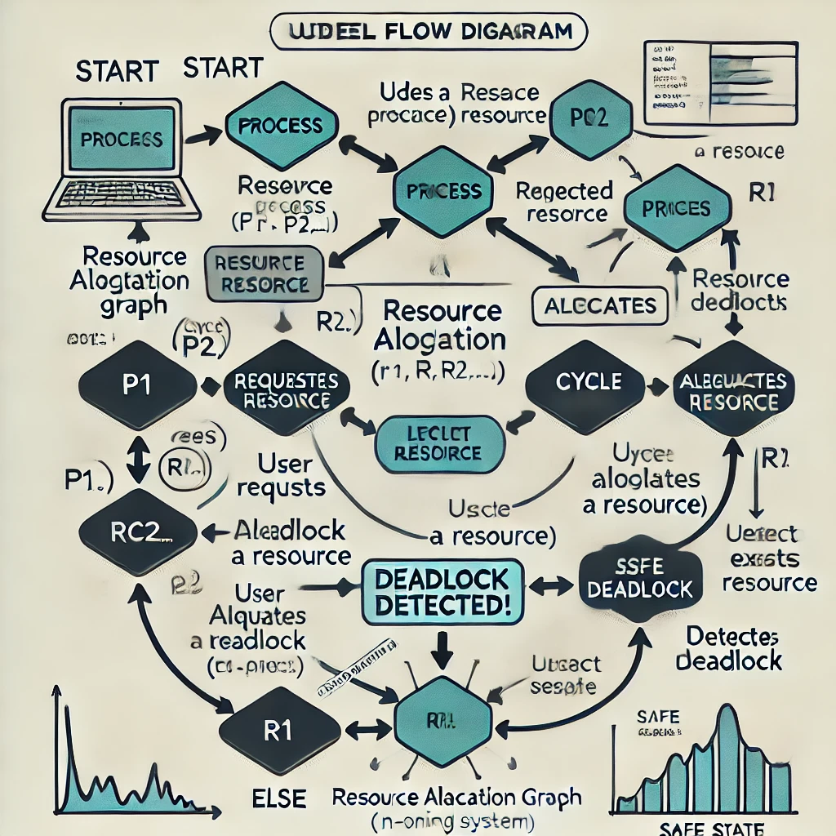

**8.Revision Tracking on GitHub:**

• Repository Name: [Insert Repository Name]

• GitHub Link: [Insert Link]

**9.Conclusion:**

The **Graphical Simulator for Resource Allocation Graphs in Operating Systems** provides a powerful, interactive, and educational tool to enhance understanding of resource allocation, process management, and deadlock detection. Traditional learning methods often rely heavily on theoretical concepts and textual explanations, making it difficult for students and researchers to visualize the complex interactions between processes and resources. This simulator bridges that gap by offering a dynamic graphical representation of **Resource Allocation Graphs (RAGs)**, allowing users to visualize, modify, and analyse various scenarios interactively.

By implementing functionalities such as **process creation, resource allocation, deadlock detection, and cycle identification**, the simulator demonstrates how real-world operating systems manage resources. Key algorithms like **Banker’s Algorithm** and **Wait-for Graph Analysis** are integrated to help users understand how deadlocks are detected and prevented. The simulator’s GUI provides an intuitive interface where users can experiment with different allocation scenarios and observe the outcomes in real time.

From an educational perspective, this tool significantly improves **learning outcomes** for students by enabling them to interactively explore concepts rather than relying solely on static textbook explanations. Educators can use it in classroom settings to demonstrate real-time resource allocation and deadlock scenarios, reinforcing theoretical knowledge with hands-on experience.

From a **research perspective**, the simulator serves as a foundational platform that can be extended for advanced studies in **operating systems, process synchronization, and distributed computing**. Researchers can modify the simulation to test new resource allocation strategies, experiment with enhanced deadlock detection mechanisms, or integrate it with real-world OS kernels for more advanced analysis.

Overall, the simulator successfully achieves its objective of **bridging the gap between theoretical understanding and practical application**. It provides users with the ability to interactively manipulate Resource Allocation Graphs, analyze deadlock conditions, and explore various resource allocation strategies in an intuitive and engaging manner.

**10.Future Scope:**

While the current implementation of the Graphical Simulator offers a solid foundation, there are numerous areas for improvement and expansion. The future scope of this project includes enhancements in usability, efficiency, functionality, and real-world application. Some of the key areas for future work include:

**10.1. Enhancing User Interface and Experience**

* Improved Graphical Representation: The current simulator uses basic matplotlib and networkx for visualization. Future improvements could include more interactive and animated visualizations with real-time updates and smoother transitions.
* Drag-and-Drop Interface: Implementing a drag-and-drop UI for adding and modifying processes/resources would make interactions more intuitive.
* Custom Themes and Layouts: Providing users with options to choose different graph layouts (hierarchical, circular, force-directed) would enhance visual clarity.

**10.2. Advanced Deadlock Detection and Recovery Mechanisms**

* Alternative Deadlock Detection Algorithms: Incorporating more
* advanced deadlock detection and resolution techniques, such as Chandy-Misra-Haas algorithm or Wait-Die and Wound-Wait strategies, would provide a more comprehensive understanding of deadlock handling.
* Deadlock Recovery Implementation: Instead of just detecting deadlocks, future versions of the simulator could provide automated recovery mechanisms, such as process termination or resource pre-emption, based on predefined recovery strategies.

**10.3. Multi-Threading and Real-Time Simulation**

* Live Resource Allocation Simulation: Future enhancements could include a real-time simulation mode, where processes dynamically request and release resources over time, providing a more realistic representation of an actual operating system environment.
* Multi-threaded Execution: Implementing multi-threading will allow the simulation to handle multiple user interactions simultaneously, improving efficiency and responsiveness.

**10.4. Integration with Real-World Systems**

* OS Kernel Integration: Extending the simulator to interact with actual operating system resource allocation mechanisms would make it a powerful tool for analysing real-world OS behaviour.
* Cloud-Based Version: Developing a web-based version of the simulator using JavaScript, React, and WebAssembly would allow users to access it remotely from any device, making it more accessible to a wider audience.
* Integration with Distributed Systems: Extending the simulator to model resource allocation in distributed computing environments (e.g., cloud computing, grid computing) would expand its applicability.

**10.5. AI and Machine Learning for Resource Optimization**

* Predictive Resource Allocation: Implementing machine learning algorithms to predict resource allocation patterns and suggest optimal allocation strategies based on past usage.
* AI-Based Deadlock Prevention: Using AI to dynamically adjust allocation policies to prevent deadlocks before they occur.

**10.6. Collaborative and Multi-User Functionality**

* Networked Multi-User Simulation: Future versions could enable multiple users to collaborate in real-time over a network, useful for classroom learning and group research projects.
* Cloud Synchronization: Implementing cloud storage support so users can save and share their simulation scenarios across different devices.

**10.7. Extended Support for Additional Algorithms and Policies**

* Implementation of More Scheduling Algorithms: Supporting First Come First Serve (FCFS), Shortest Job Next (SJN), and Round-Robin Scheduling to complement resource allocation features.
* Priority-Based Resource Allocation: Introducing priority scheduling and dynamic resource allocation policies for more complex simulations.

**10.Final Thoughts**

The Graphical Simulator for Resource Allocation Graphs has great potential as an educational and research tool. By providing an interactive visualization of process-resource interactions, deadlock scenarios, and resource allocation strategies, it significantly enhances learning, experimentation, and problem-solving in the field of operating systems.

The simulator currently serves as a stepping stone for further development in resource allocation research, algorithm testing, and operating system education. With future enhancements, it could evolve into a comprehensive platform for OS learning, real-time process management analysis, and AI-driven resource allocation optimization.

By continuously improving and expanding the simulator’s features, algorithms, and usability, we can make it a more robust, scalable, and widely adopted tool in academia, research, and industry applications. The future of this project holds immense potential for advancing the way resource allocation and deadlock management are understood, analysed, and applied in modern computing systems.

**11.FINAL CODE**

import tkinter as tk

from tkinter import messagebox, simpledialog

import networkx as nx

import matplotlib.pyplot as plt

from matplotlib.backends.backend_tkagg import FigureCanvasTkAgg

# Module 1: GUI & User Interaction

class GUI:

def __init__(self, root, graph_handler):

self.root = root

self.root.title("Resource Allocation Graph Simulator")

self.graph_handler = graph_handler

# UI Buttons

self.add_process_btn = tk.Button(root, text="Add Process", command=self.graph_handler.add_process)

self.add_process_btn.pack(pady=5)

self.add_resource_btn = tk.Button(root, text="Add Resource", command=self.graph_handler.add_resource)

self.add_resource_btn.pack(pady=5)

self.add_request_btn = tk.Button(root, text="Request Resource", command=self.graph_handler.request_resource)

self.add_request_btn.pack(pady=5)

self.add_allocation_btn = tk.Button(root, text="Allocate Resource", command=self.graph_handler.allocate_resource)

self.add_allocation_btn.pack(pady=5)

self.detect_deadlock_btn = tk.Button(root, text="Detect Deadlock", command=self.graph_handler.detect_deadlock)

self.detect_deadlock_btn.pack(pady=5)

self.show_graph_btn = tk.Button(root, text="Show Graph", command=self.graph_handler.show_graph)

self.show_graph_btn.pack(pady=5)

# Module 2: Graph Data Handling & Deadlock Detection

class GraphHandler:

def __init__(self, update_graph_callback):

self.graph = nx.DiGraph() # Directed graph

self.processes = set()

self.resources = set()

self.update_graph_callback = update_graph_callback

def add_process(self):

process = simpledialog.askstring("Input", "Enter Process Name (e.g., P1):")

if process and process not in self.processes:

self.processes.add(process)

self.graph.add_node(process, color='lightblue', shape='o') # Light blue for process

self.update_graph_callback(self.graph) # Pass the graph

else:

messagebox.showerror("Error", "Process already exists or invalid input.")

def add_resource(self):

resource = simpledialog.askstring("Input", "Enter Resource Name (e.g., R1):")

if resource and resource not in self.resources:

self.resources.add(resource)

self.graph.add_node(resource, color='gray', shape='s') # Gray for resource

self.update_graph_callback(self.graph) # Pass the graph

else:

messagebox.showerror("Error", "Resource already exists or invalid input.")

def request_resource(self):

process = simpledialog.askstring("Input", "Enter Process Name:")

resource = simpledialog.askstring("Input", "Enter Resource Name:")

if process in self.processes and resource in self.resources:

self.graph.add_edge(process, resource, color='orange') # Request edge

self.update_graph_callback(self.graph) # Pass the graph

else:

messagebox.showerror("Error", "Invalid Process or Resource.")

def allocate_resource(self):

resource = simpledialog.askstring("Input", "Enter Resource Name:")

process = simpledialog.askstring("Input", "Enter Process Name:")

if resource in self.resources and process in self.processes:

self.graph.add_edge(resource, process, color='green') # Allocation edge

self.update_graph_callback(self.graph) # Pass the graph

else:

messagebox.showerror("Error", "Invalid Resource or Process.")

def detect_deadlock(self):

try:

cycles = list(nx.simple_cycles(self.graph))

if cycles:

messagebox.showwarning("Deadlock Detected!", f"Deadlock in: {cycles}")

else:

messagebox.showinfo("No Deadlock", "No deadlock detected.")

except Exception as e:

messagebox.showerror("Error", str(e))

def show_graph(self):

self.update_graph_callback(self.graph) # Pass the graph

# Module 3: Data Visualization & Simulation

class GraphVisualizer:

def __init__(self, root):

self.figure = plt.Figure(figsize=(6, 6))

self.canvas = FigureCanvasTkAgg(self.figure, master=root)

self.canvas.get_tk_widget().pack(pady=5)

def update_graph(self, graph):

self.figure.clear()

pos = nx.spring_layout(graph)

node_colors = [graph.nodes[n].get('color', 'black') for n in graph.nodes]

edge_colors = [graph[u][v].get('color', 'black') for u, v in graph.edges]

nx.draw(graph, pos, with_labels=True, node_color=node_colors, edge_color=edge_colors,

node_size=1500, font_size=10, ax=self.figure.add_subplot(111))

self.canvas.draw()

# Run GUI

if __name__ == "__main__":

root = tk.Tk()

visualizer = GraphVisualizer(root)

graph_handler = GraphHandler(visualizer.update_graph)

app = GUI(root, graph_handler)

root.mainloop()

**12.SOLUTION OF CODE**

**1🡪Deadlock occur!!**

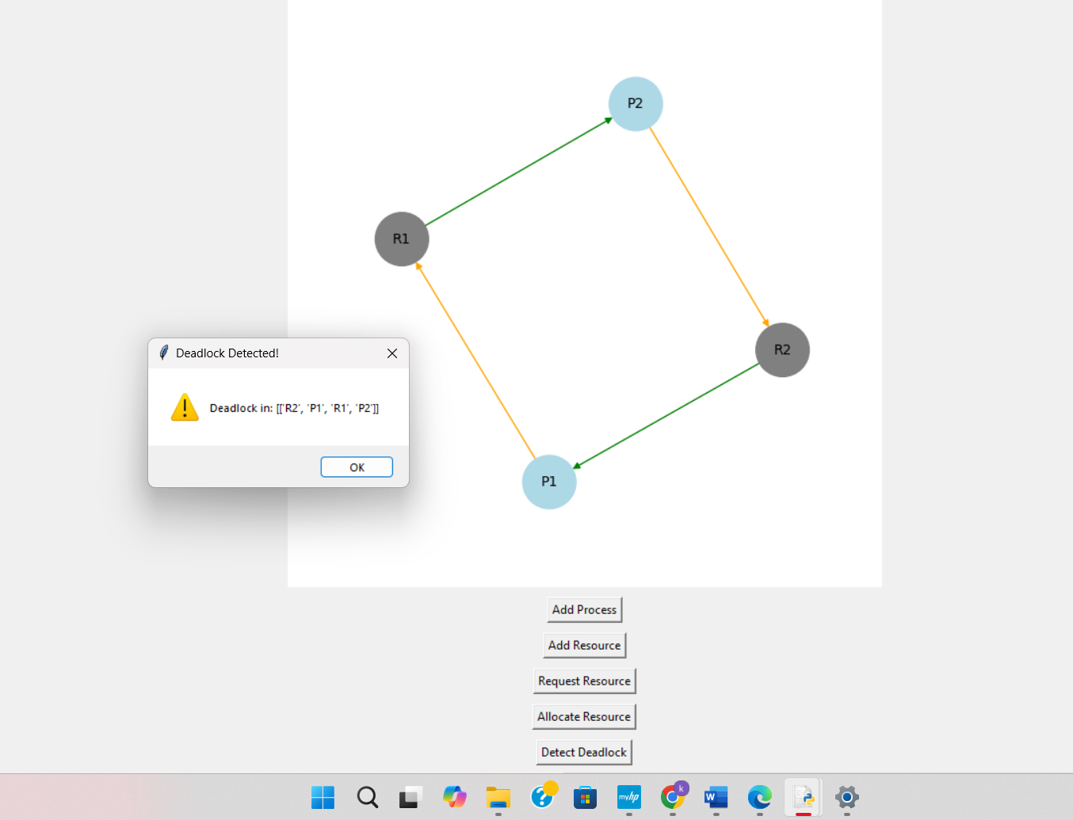

**2🡪No Deadlock Occur**

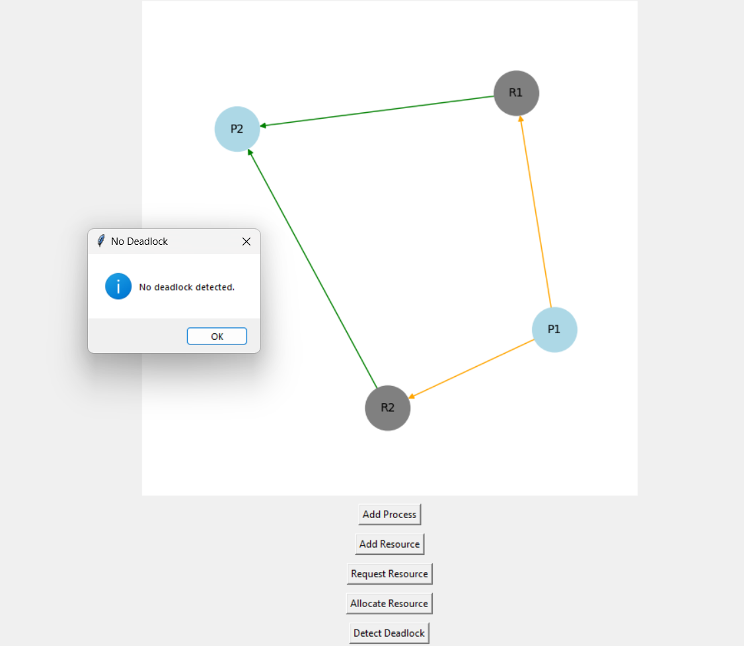

**THE END**